NETWORK LOAD MANAGER
An Intelligent Network Load Balancing System

ABSTRACT

In this report, we describe the process of developing a Network Load Balancing system from design to implementation.

When a single Server machine isn't enough to handle the traffic on the network tit's time to look into building a web Farm that uses multiple machines on the network l acting as a single server. A Web Farm is a not so fancy term for a collection of servers [that act as a single Web server. Administration of two or more servers and keeping them properly synched is actually a lot more work than administering a single server.

The Load Balancing can also provide benefits in the overload scenario. For one, tit's generally cheaper to throw mid-level machines at a load problem rather than buying lone top of the line high end machine.

CONTENTS

Serial No Description
Page No

- INTRODUCTION
- SOFTWARE REQUIREMENT SPECIFICATION
2.1 Introduction
- Purpose
- Scope
- Developer's Responsibilities Overview
2.2 General Description
- Product Function Overview
- User Characteristics
- General Constraints
2.3 Specific Requirements
2.3.1 External Interface Requirements
2.3.2 Functional Requirements
- Performance Constraints
- Design Constraints
- Security
- Maintainability
- Acceptance Criteria DESIGN DOCUMENT
3.1 Introduction
- Purpose
- Scope

- Module Decomposition
- Data Decomposition
1 2
2 2 2 2 2 2 3 3 3 3 4 5 5 5 6 6 7 7 7 7 7 8

Serial No Description
Page No

5 6 7
3.4 Dependency Description
3.4.1 Data flow diagrams
- Database Design
- Form Diagrams
- Use Case Diagrams
- Sequence Diagrams
- Interface Description TESTING & IMPLEMENTATION
4.1 Testing
* 4.1.1 White Box Testing
4.1.2 Black Box Testing
4.2 Implementation
SCREEN SHOTS
CONCLUSION
8 9
14
16 20 22 24 25 25 26 26 26 27 30

APPENDIX REFERENCE
32 50

INTRODUCTION
INTRODUCTION

In this report, we describe the process of developing a Network Load Balancing system from design to implementation.

When a single Server machine isn't enough to handle the traffic on the network [ it's time to look into building a web Farm that uses multiple machines on the network
acting as a single server. A Web Farm is a not so fancy term for a collection of servers [that act as a single Web server. Administration of two or more servers and keeping
them properly synched is actually a lot more work than administering a single server.

The Load Balancing can also provide benefits in the overload scenario. For one, [it's generally cheaper to throw mid-level machines at a load problem rather than buying [one top of the line high end machine.

Load Balancing also provides something else that has nothing to do with scalability: [The ability to have failover support if something goes wrong on one of the servers in the fpool. Because a Web Farm is made up of essentially identically configured servers, a failure on a single server will not bring down the entire server contents. Other servers in pie pool can continue to process requests and pick up the slack. For many companies f this feature of load balancing is often important for peace of mind both in the knowledge [that a single point of failure on the Server is avoided as well as providing an in place tmechanism to grow the application should the need arise at a later point.
SOFTWARE REQUIREMENT SPECIFICATION
1. INTRODUCTION

1.1Purpose

The main purpose of this document is to describe the external requirements
for Network Load Balancing system. It also describes the interfaces for the system.

1.2 Scope

This document is the only one that describes the requirements of the system. It meant for use by the developers and will be the basis for validating the final delivered system. Any changes made to the requirements in the future will have to go through a formal change approve process. The developer is responsible for asking clarifications, where necessary, and will not make any alterations without the permission of the client.

1.3 Developer's Responsibilities Overview

The developer is responsible for
- Developing the system
- Installing the software on the inter mediate server and the clients hardware.
- Conducting any user training that might be needed for using the system,
and
(d) Maintaining the system for a period of one year after installation

2. GENERAL DESCRIPTION 2.1 Product Function Overview

The layout of this project is given below:
- Login
- Administration or Agent Soft
- Add/Remove server
- Add/Remove client
- Download Allocation
- Change password

- Generating reports -Help
- User
- Messaging
- Downloading/Uploading
- Change password -Help
- Logoff

2.2 User Characteristics
This software is so user friendly to any user who has worked in windows Operating System can be able to use this software.

The user's criteria have been sub divided in to

\ Administrator: has the overall control of the system. He/she can modify the structure of
[the system.

^Registered User: the one who familiar with the system and he/she has their own Login Id and Password.

2.3 General Constraints

The system should run on windows 2000 onwards any operating system.

[3. SPECIFIC REQURIEMENTS

I 3.1 External Interface Requirements 3.1.1 User Interfaces

If the user is valid, that is he/she has registered with the system and has logged on with a user name and password that is present in the database of the Inter mediate server, and a positive response is initiated by the inter mediate server then the user can enter in to client module.
3.1.2 Software Interfaces 3.1.2.1 Add/Remove Server

The Add/Remove server option available to the administrator of the system, to I add a new server and remove the existing one.
A table named serverdetails, ip, cpuusage, created in the database that takes care of what ever data is to be manipulating use this interface.

[3.1.2.2 Add/Remove client

The Add/Remove client option available to the administrator of the system, to I add a new client and remove the existing one.

A table named ip, clientdetails, created in the database of the inter mediate server takes care of what ever data is to be handled using this interface.

3.1.2.3 Download Allocation
The Download Allocation option for the administrator can allocate files to
| download.
3.1.2.4 Messaging
Using Messaging option in the client side, a registered user can send [ unicast message to all the servers connected.
3.1.2.5 Download/Upload
Using the Download/Upload interface in the client side a registered user can download or upload files to or from a least loaded server. 13.1.2.6 Logoff
Using this option a registered user can signup from the system. I 3.2 Functional Requirements
1. Registered User Login:
- User submit id and password
- If he/she has a valid id and password the user can enter in to product list.
2. If the registered is entering a fault password give provision to re enter the id
I and password.
3.3 Performance Constraints

In order to utilize the Network Load Manager features, need three machines tunning Windows 2000 or higher. Each machine needs to have at least one network card and at least one fixed IP address.

In addition you will also need one more machine for testing (4 machines | total). The test machine should be external can't use a machine from the pool to test.

3.4 Design Constraints
3.4.1 Software Constraints

The application is developed by using J2EE, XML, JavaSwing, Apache TomCat 15.0 web browser,RMI-IIOP, SQLServer2000 database and is well functioned under any [ operating system.

3.4.2 Hardware Constraints
Pentium 4.28GHz
256 MB RAM
40 or 80 GB hard disk
Standard 101 Keyboard
Standard 2 button mouse
Backup: CD ROM/Hard Disk/Zip...

3.4.3 Network Connections
Cat5 cables, RJ45 connectors, Hub or Switch.

3.5 Security
Security come prime importance in public interface software. The : Administrator mode is completely secure from the operational mode. The Administrator is asked for proper authentication before entering a registered user into the system. The user can't make changes to the database's critical data area.
3.6 Maintainability
The Database has to be constantly updated according to the changes coming in System administrator should keep proper check to the changing needs of the user and there by making appropriate changes to the database.

3.7 Acceptance Criteria

Before accepting the system, the developer must demonstrate that the system works properly. The developer will have to show through test cases that all conditions are satisfied.
DESIGN DOCUMENT
1. INTRODUCTION
1.1 Purpose

The purpose of this document is to describe external and internal interface of this fcystem. It explains in details about various modules incorporated in the project, using FER diagrams, relational database Tables, form representations and DFDs.lt gives a representation of external out look of the project.
1.2 Scope

The System Design Document describes how to transform the requirements and the functional design into more technical system design specifications. Definitions and acronyms

DFD: - The Data Flow Diagram is a graphical representation that depicts ^information flow and the transforms that are applied as data move from input to output. It [ aims to capture the transformations that take place with in a system to the input data so that eventually the output data is produced. DFDs are very useful in understanding a ^system and can be effectively used during analysis.

Modules: - Software is divided in to separately named and addressable [components, often called modules, that are integrated to satisfy problem requirements.

[2 MODULE DECOMPOSITION

The entire project is divided in to two different modules. Administrative and user
module.

Administrative module: this module provides the administrator login, which have options for the effective administrative tasks. They are:

Add/Remove server Add/Remove client Download Allocation Change password
Generating reports Help

User module: this module provides the user login, which have options for the effective user operations. They are:
Messaging
Downloading/Uploading Change password Help Logoff

3. DATA DECOMPOSITION

Login: this table is used to keep the username, password and permission type of the
user.

Serverdetails: this table is used to keep the details of the servers connected to the inter
mediate server.
Clientdetails: this table is used to keep the client details such as computername, logintime, logindate, loginid etc.
ip: this table is used to keep the details of all nodes connected to the inter mediate server both clients and servers. Computername, ipaddress and systemtype is stored to
this table.
Userdetails: this table is used to keep the user details such as loginid, username, address, phone, email etc.
Userstatus: this table is used to keep the user details such as loginid, status, computername.

4. DEPENDENCY DESCRIPTION

It gives in detail about the different modules on which this project is dependent. DFD used to show the flow of data between various components of the modules, which gives an idea of how the entire project implements.
4.1 Data flow diagrams
CLIENT
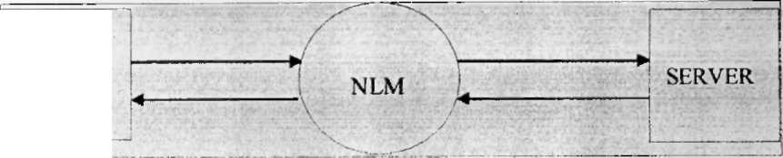

iLevel 0:
SERVER
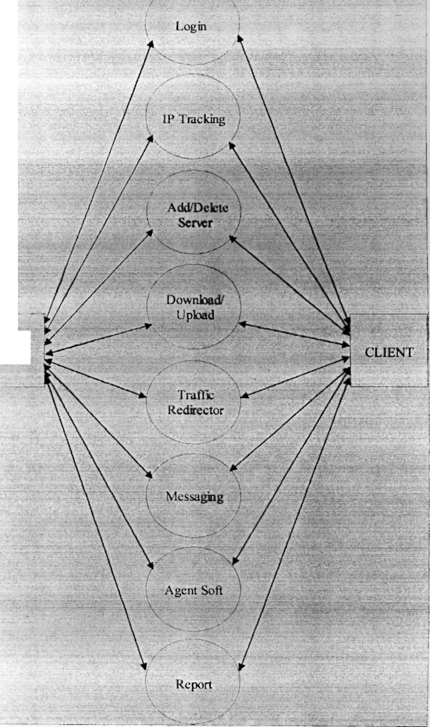
: Level 1:
Level 2;Login
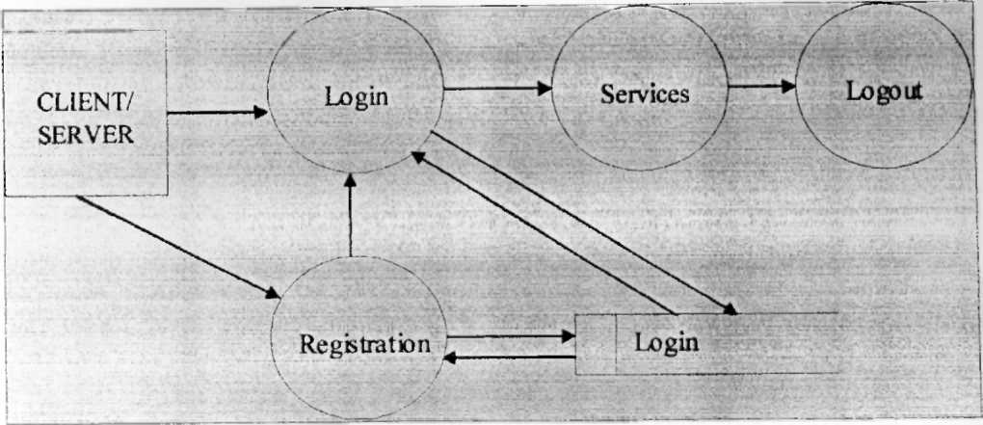

Level 3: IP Tracking
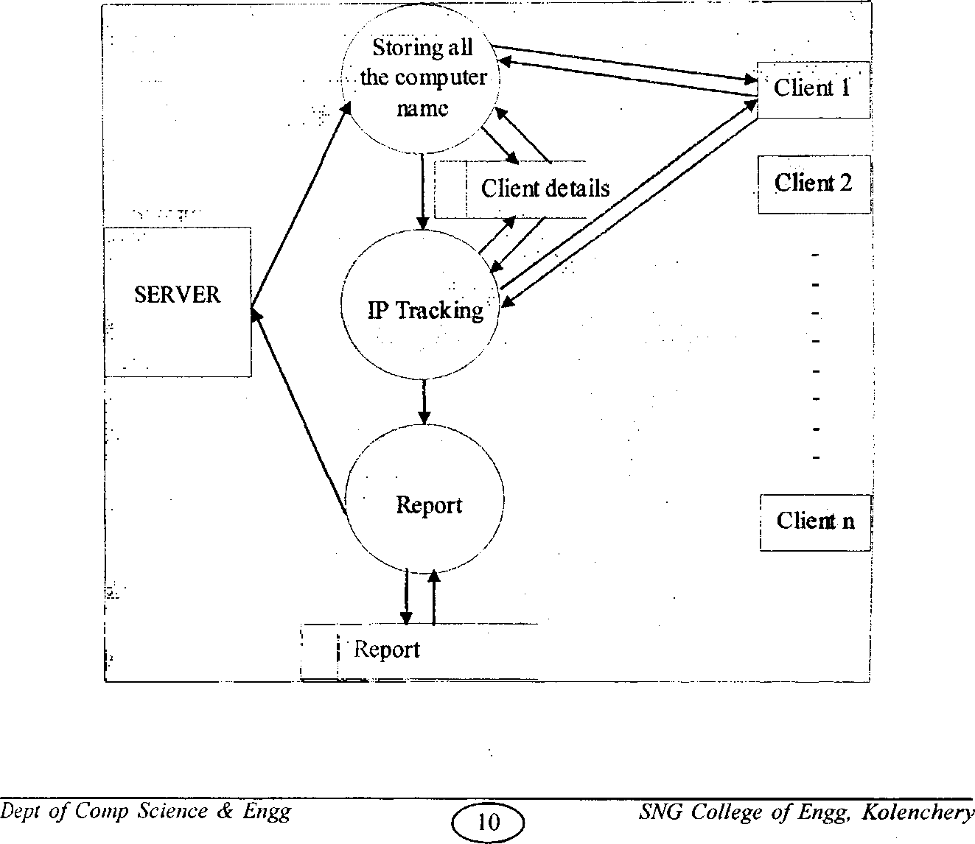
Level 4:Add/Delete Server
Client details
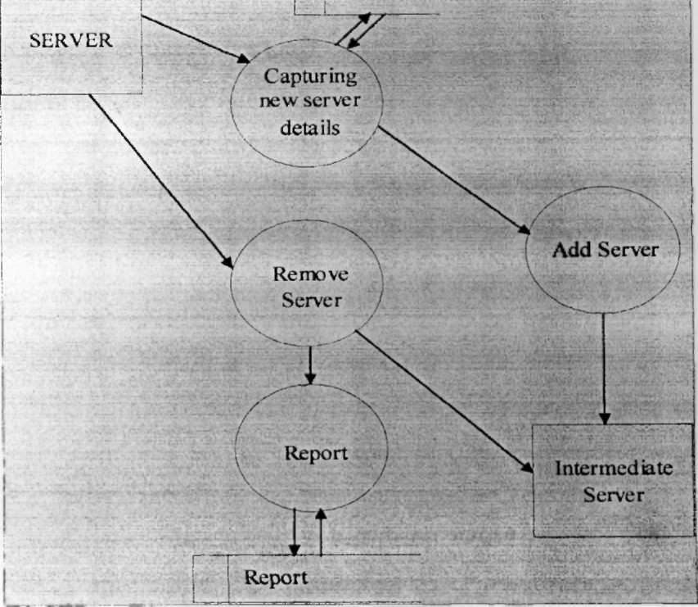

Level 5:Download/Upload
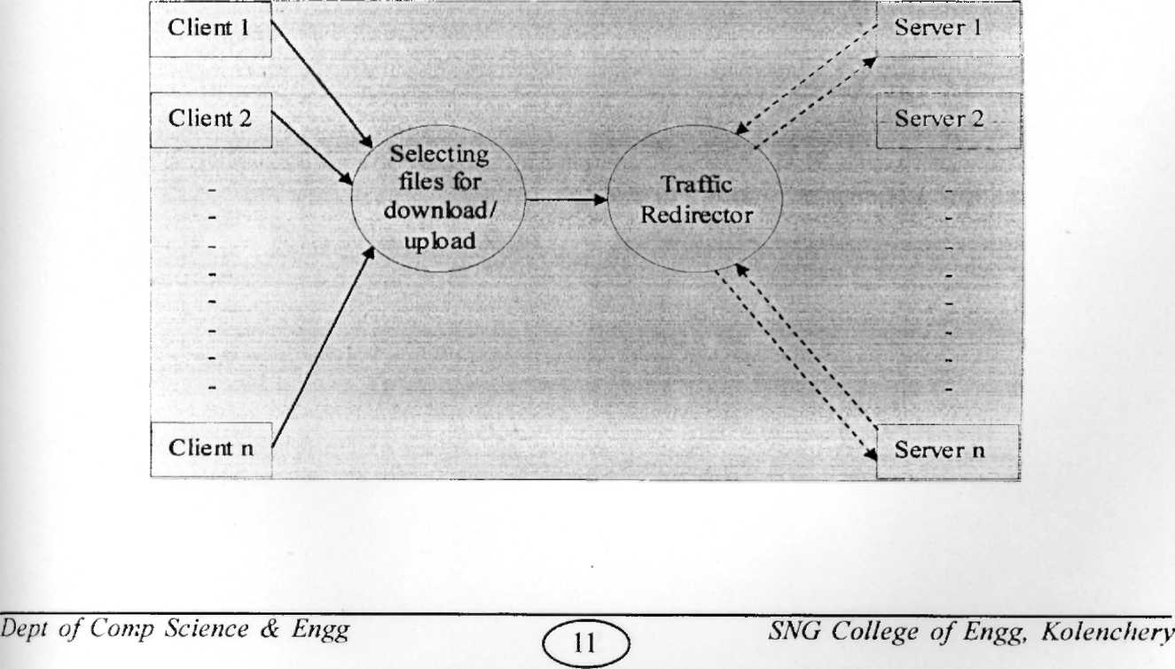
Level6:Traffic Redirector

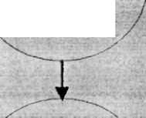
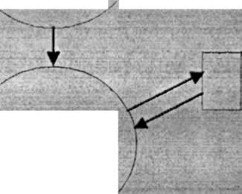
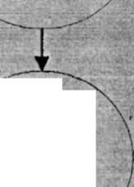
Sending Request
Comparing CPU usage
Finding
least loaded server
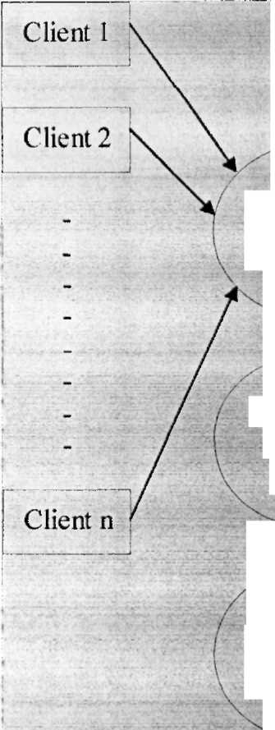
Processing client request /
CPU usage

Server 1

Sending Request
Server 2

Server n

Project Report - June 2006 Level 7:Messaqing
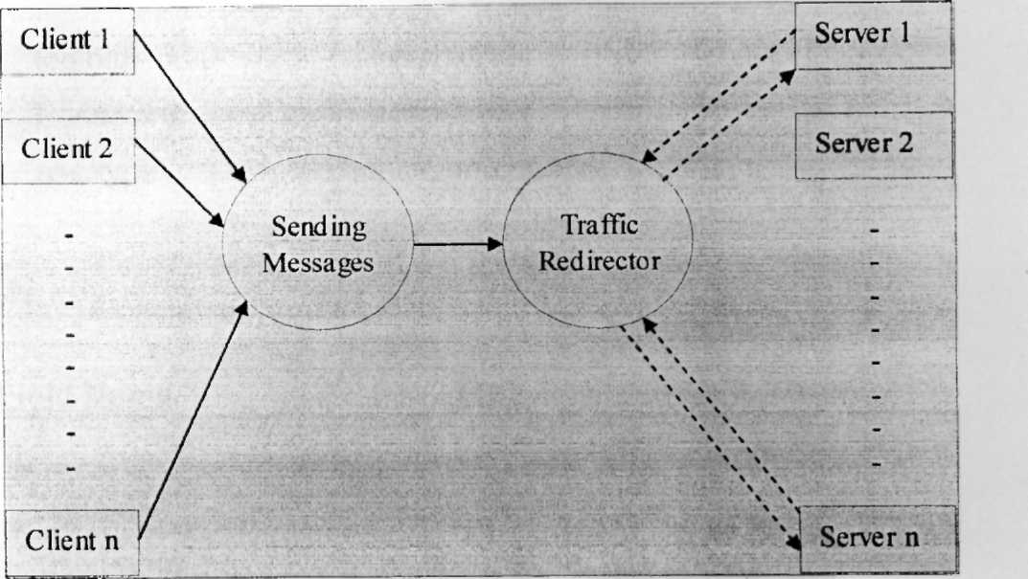

Level 8: Agent Soft
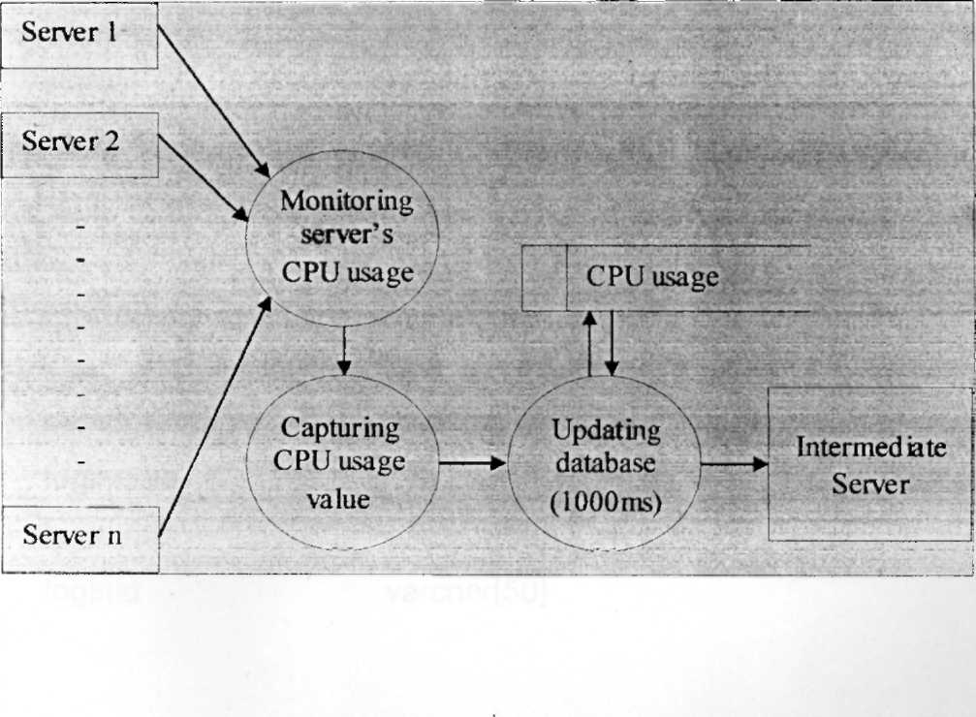
5. Database design Login:

Field Name
Type

loginid
Password
usertype
varchar[50] varchar[50]
varchar[50]

[Userdetails:

Field Name
Type

loginid
username
Address
Email
Phone
varchar[50]
varchar[50]
varchar[50] varchar[50] varchar[50]

Userstatus:

Field Name
Tvpe

loginid status
computername varchar[50] varchar[50] varchar[50]

Clientdetails:

Field Name
Tvpe

computername logintime logindate loginid
varchar[50] varchar[50] varchar[50] varchar[50]

Serverdetails:

Field Name

computername
ostype
osversion
fcpuusage:
Field Name
computername
usage
id
logout:
Field Name

computername
loginid
logouttime
Type

varchar[50]
varchar[50] varchar[50]

Type

varchar[50] varchar[50]
varchar[50]

Type

varchar[50]
varchar[50] varchar[50]

[6.Form Design
Login :

LOGIN

User Type
User name Password

Login
' Cancel

Administrator:

Administrator

Operations"
View
Help

Add Server
Reports
Help Topic

Remove Server
CPU Usage
lAbout*

Add Client
Remove Client.
Download allocation
Change Password
Exit
User:
User-

Service
Hefc

Messaging
Help Topic

Download/ Upload
About

Change . Password

Exit

[Add Server:

New Server

Server Name L
J IP Address I

Add
Cancel

Change Password:

Change Password

User Name Old Password New Password

Confirm Password

OK

Cancel

Remove Server:

Remove Server

Server Name IP Address
32

Remove
Cancel

Add Client:

New Client/System
ComnuterName IP Address

Add
Cancel

User Information:

User Information

User Name |
Login id [
Password [
Re-type password [

Add
Cancel

Address E-mail

Phone L~

iRemove Client:

Remove Client/System
Computer Name IP Address

Remove
Cancel

CPU Usage:

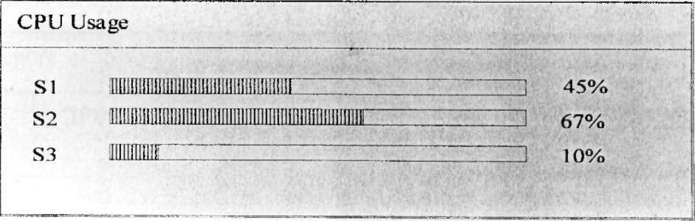

Messaging:
Messaging

Type your Message Here

Send
Cancel

Server Report
Server Report
Server | IP Address | CPU Usage
....
[Client Report
Client Report ■

Client
IP Address
User
Login Time
Login Date

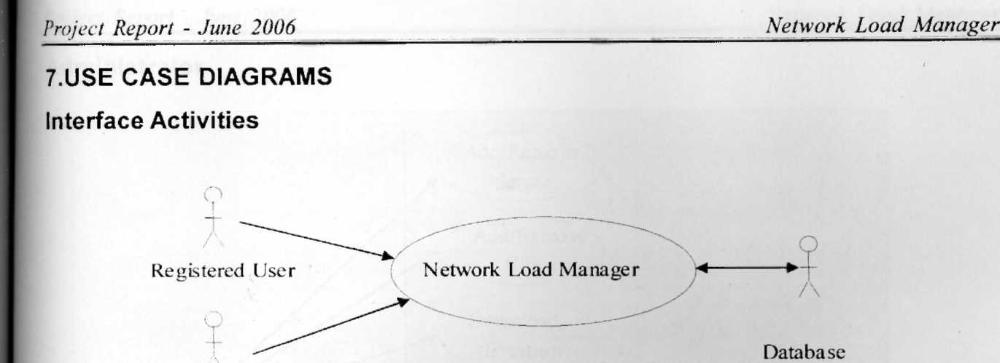
Registered User
Ad ministrator
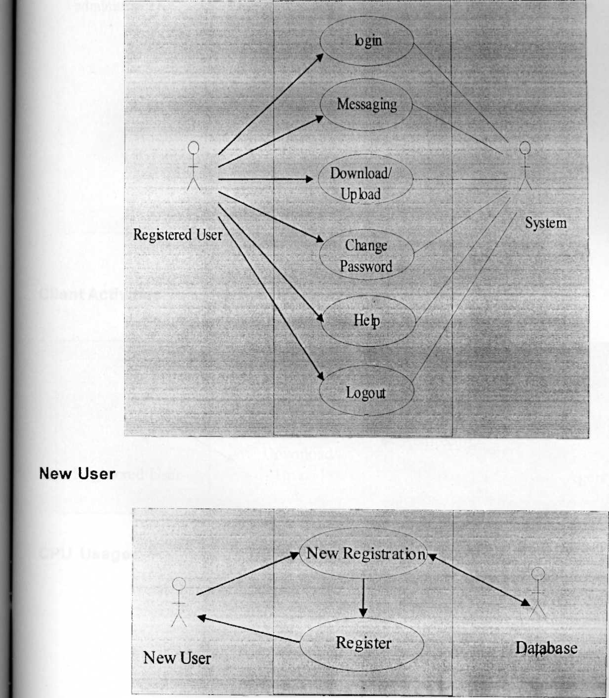
Administrator

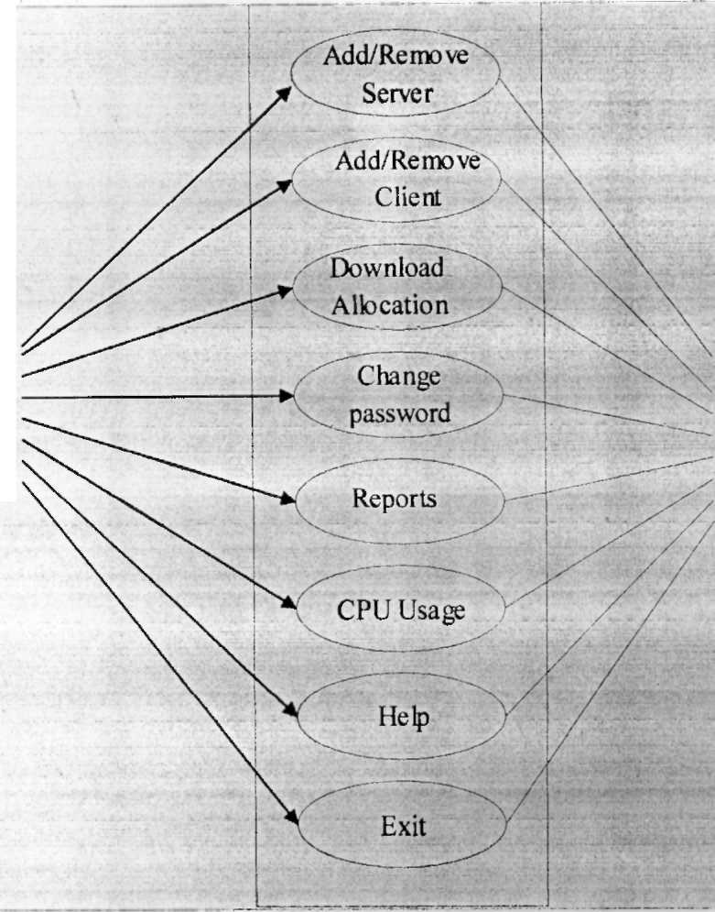
administrator
System

A

Client Activities

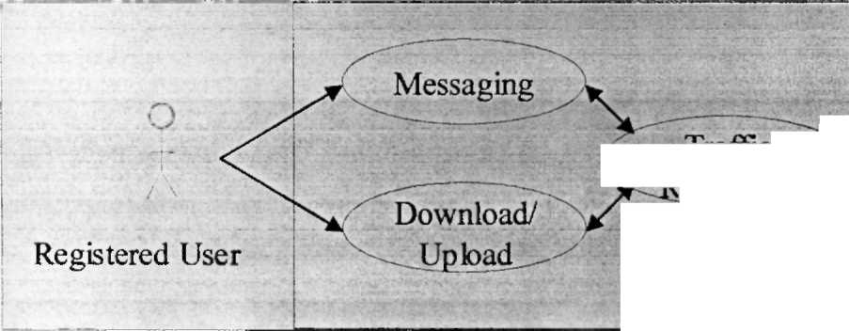
lrajuuc ^W-
- ^edirector-^

O A
Agent Soft

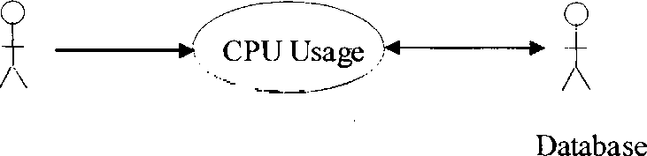
[CPU Usage
Agent Soft

8. Sequence Diagrams: Login

o
A
Registered User

Check:class login

Login, iava

Database

! 1 user submit id.Dassword ■ '
rS 2:checks for id, password

3:id and password is found
4: calls login.java

5:usergets the services
3: id and password is found

7:userid, password not found
8:invalid login,Iogin again

6:userid not found

Messaging

A Client
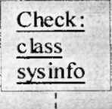
Traffic redirector : class
cp>r\H mpcc g
Least loaded server :c lass

Database

il Send message ;
2^-heck for leasy loaded server

^redirection
4lshow messagg
Download/Upload

TrafficLeastredirectorloaded: classserverxlass: usermenuuserrrtenu
3xheck for least loaded server
/
Client Browser, jsp

Check:
class
svsinfo

^Database

, 1 download ■ /upload !
2 download
/upload'^

7:return to user options

6:retum
4!redirectio!n
5 download/
upload files

9. INTERFACE DESCRIPTION
The modules of this project are: ;9.1 Add/Remove Server

The Add/Remove server option available to the administrator of the I system, to add a new server and remove the existing one.

A table named serverdetails, ip, and cpuusage, created in the database that I. takes care of what ever data is to be manipulating use this interface.

9.2 Add/Remove client

The Add/Remove client option available to the administrator of the system, to ; add a new client and remove the existing one.

A table named ip, clientdetails, created in the database of the inter mediate server takes care of what ever data is to be handled using this interface.

9.3 Download Allocation

The Download Allocation option for the administrator can allocate files to I download.

9.4 Messaging

Using Messaging option in the client side, a registered user can send unicast | message to all the servers connected.
9.5 Download/Upload

Using the Download/Upload interface in the client side a registered user can download or upload files to or from a least loaded server.
9.6 Logoff

Using this option a registered user can signup from the system.
TESTING & IMPLEMENTATION
1. TESTING

System testing is the stage of implementation, which is aimed at ensuring that [the system works accurately and efficiently as expected before live operation commences. m certifies that the whole set of programs hang together. System testing requires a test plan that consists of several keys, activities and steps for running a program. The [implementation of newly designed package is important in adopting a successful new ■system.

Testing is an important stage in software development. The system test is 'implementation stage in software development. The system test in implementation should [be confirmation that all is correct. It is an opportunity to show the users that the system [works as expected. It accounts the largest percentage of technical effort in the software [development process. Testing phase in the development cycle validates the code against [the functional specification. Testing is very important to the achievement of the system goals. The objective of testing is to discover errors. To fulfill this objective a series of test >step unit integration, validations and system tests were planned and executed.

Software Testing is the critical element of software quality assurance and . represents the ultimate review of specification, design and coding. This process is so important that nearly 40% of the total cost incurred in project effort is on testing.

The testing process can be classified into two major stages:
- Setting the testing objectives.
- Making the test case design to meet the overall objective of testing.

The general rules of testing could be as follows
-Testing is a process of executing a program with the intention of finding an error.
- A good test case is one that has a high probability of finding an undiscovered error.
- A successful test is one that uncovers the undiscovered errors.
- Tests are conducted and results are evaluated with the expected results. When erroneous data is encountered debugging commences.
NerworkLoad Manager

1.1 White Box Testing
White box testing is a testing case design method that uses the control structure L the procedural design to derive the test cases. The entire independent path in a module is exercised at least once. All the logical decisions are exercised at least once. Executing all the loops at boundaries and within their operational bounds exercise internal data structure to ensure their validity.
1.2 Black Box Testing
These attempts to find errors in the following areas or categories: Incorrect or [missing functions, interface errors, errors in data structures, external database access, [performance errors and initialization errors.

The system is tested via white box and black box testing approaches for logical [errors, typographical errors, interface errors etc. Each module is tested in different [phases. Validation is done in different modules. And the whole system is tested by using [minimal of four systems as two servers, intermediate server and one client and the system worked properly.

2. IMPLEMENTATION
Implementations is the process of having systems personnel check out and put [the new equipment in to use, train the users to use the new systems. We test the performance of the new system for a period of time. In the testing period we can correct and update the project again. Implementation is the stage of a project when the [theoretical design is turned into a working system. If the implementation stage is not [carefully planned and controlled, it can cause chaos. The implementation stage is a systems project in its own. Implementation is the stage of the project where the theoretical [design turns into a working system. Thus it can be considered to be the most crucial [stage in achieving a successful new and giving the users confidence that the new system [will work and be effective and accurate. It is less creative than system design. It is primarily [concerned with user training and site preparation.

Depending on the nature of the system, extensive user training may be required. Implementation simply means converting a new system design into operation. An important aspect of the system analyst's job is to make sure that the new design is implemented to establish standards. Implementation means the process of converting a new raised system design into an operational one.
SCREEN SHOTS
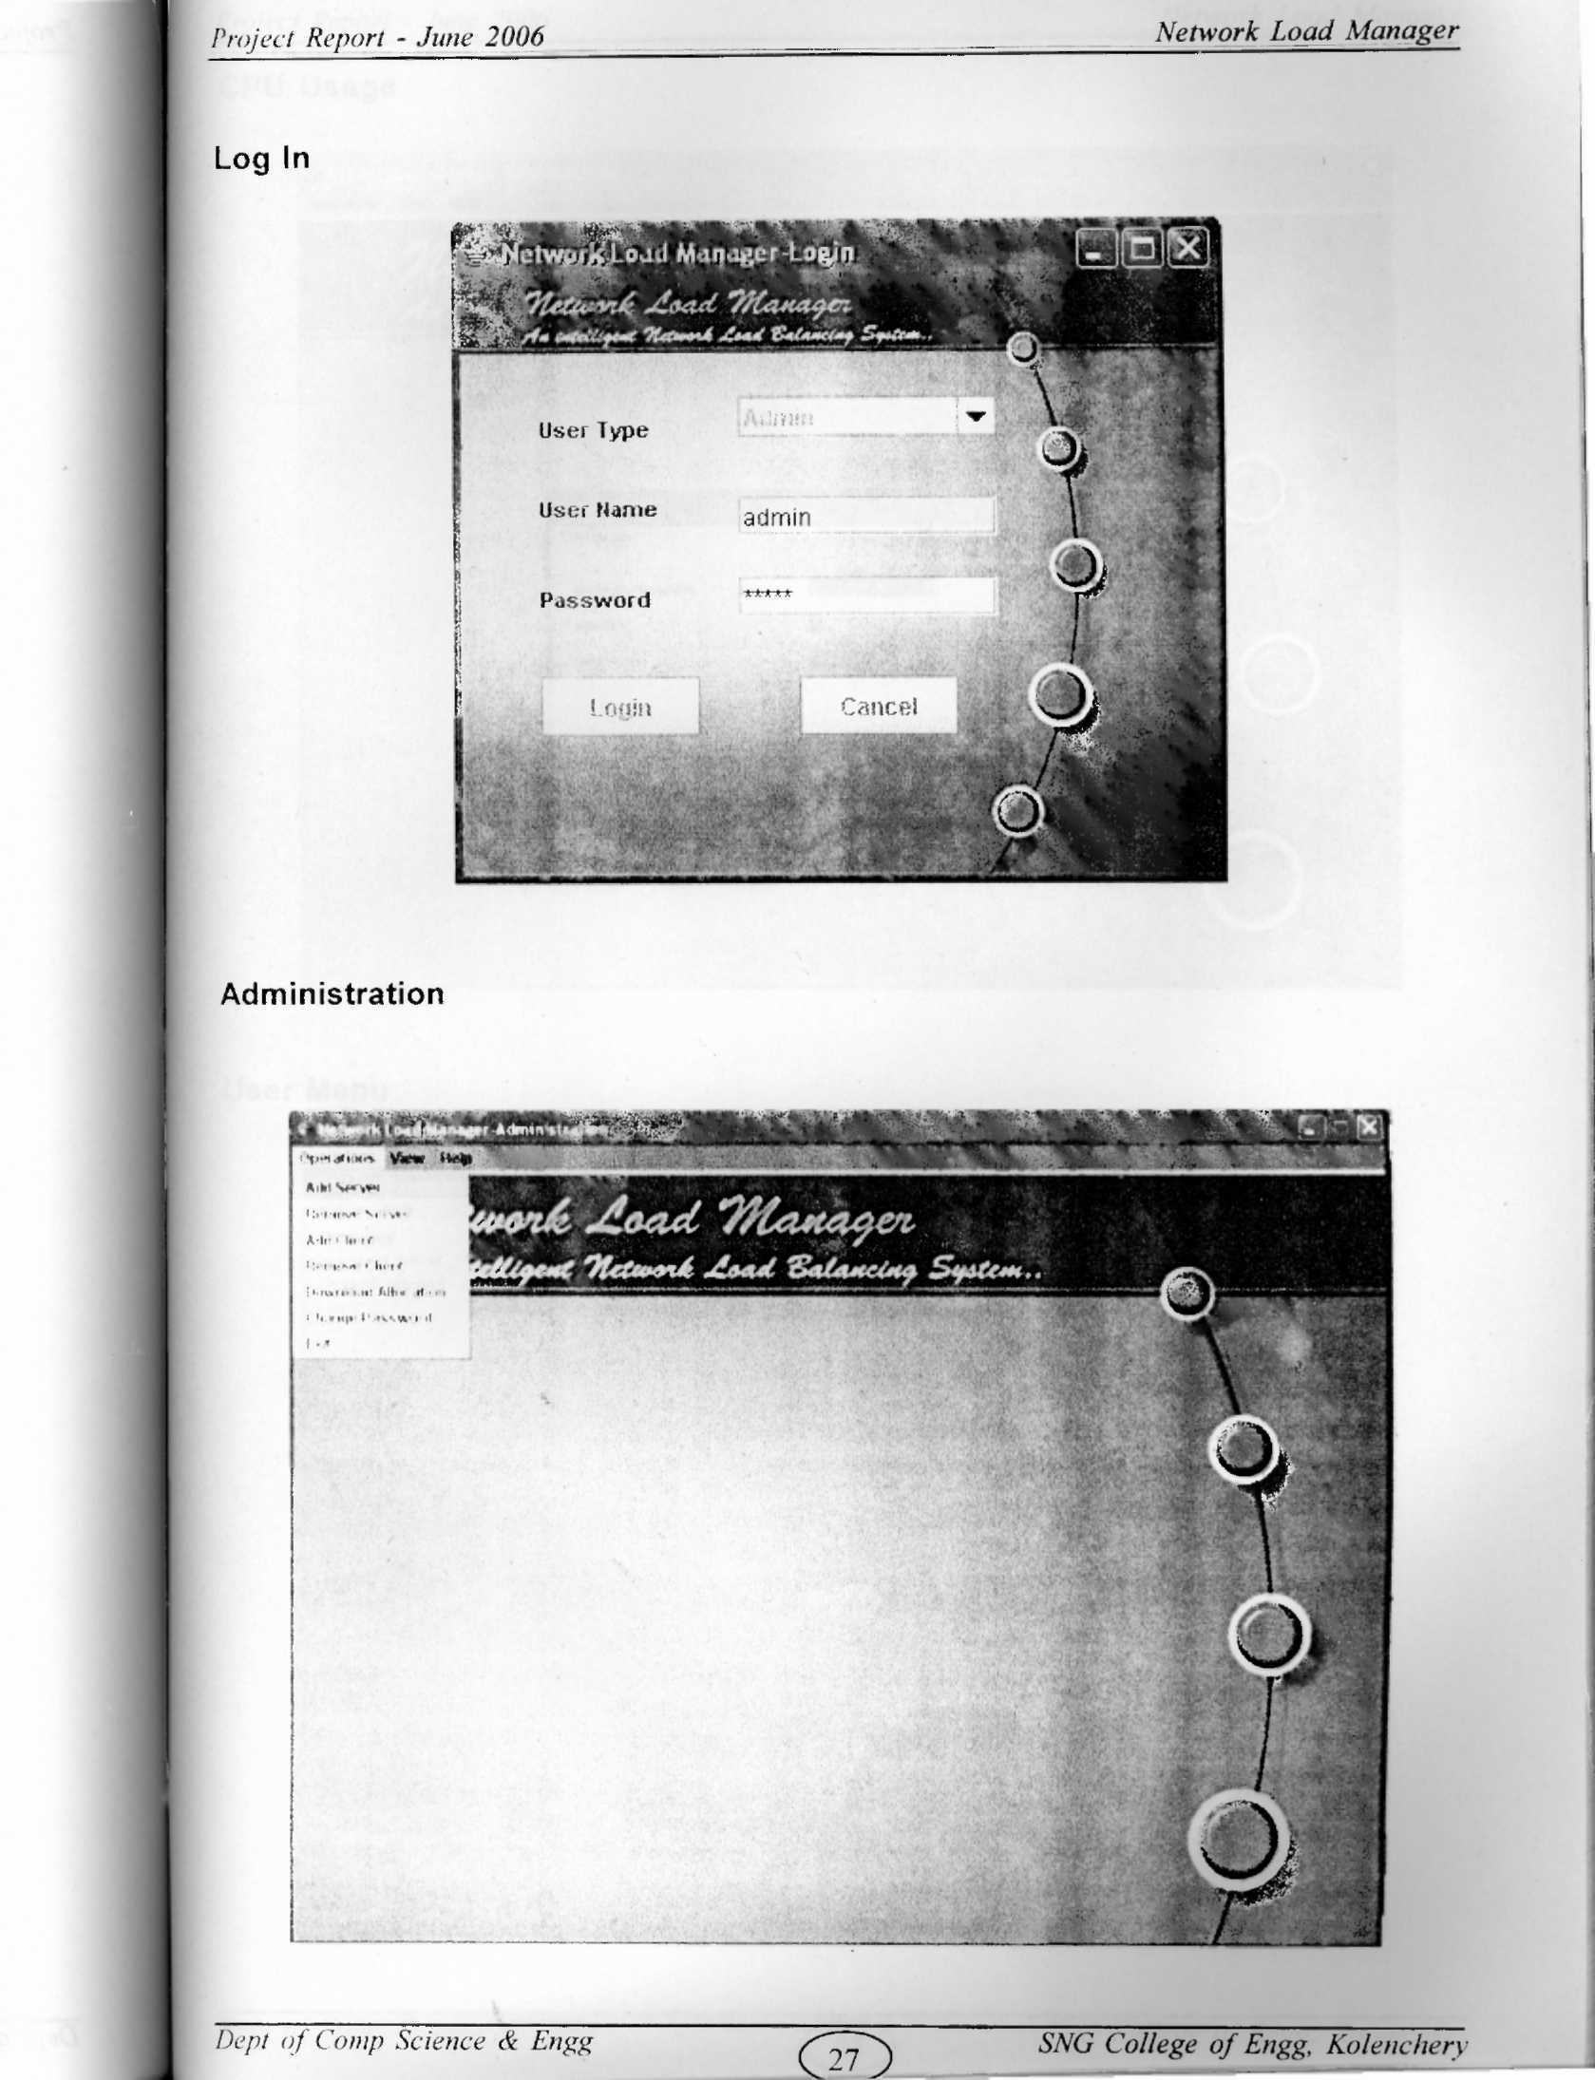
^CPU Usage

User Menu
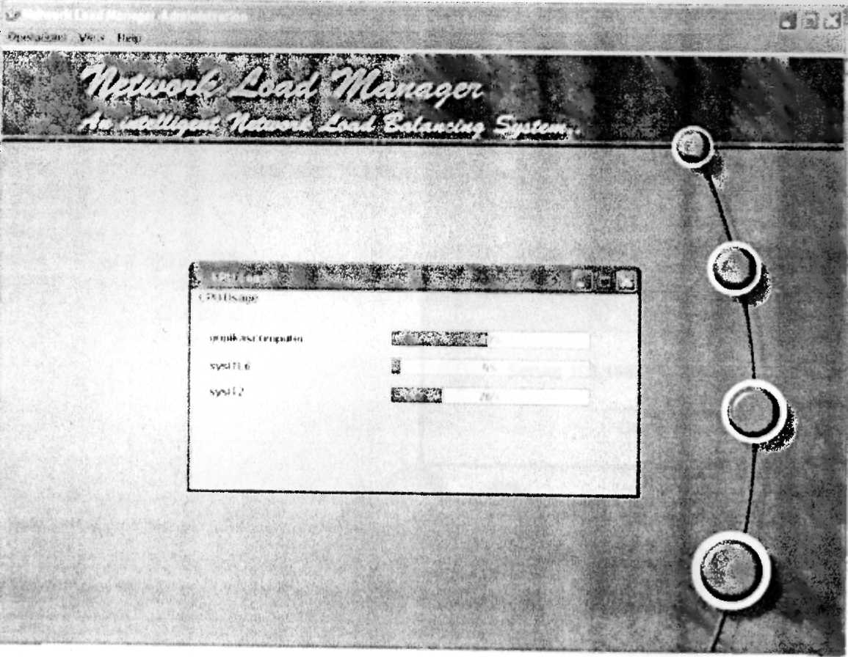


I >MMil I. ti r|| |«i „|

1 «u i if...



Send Message

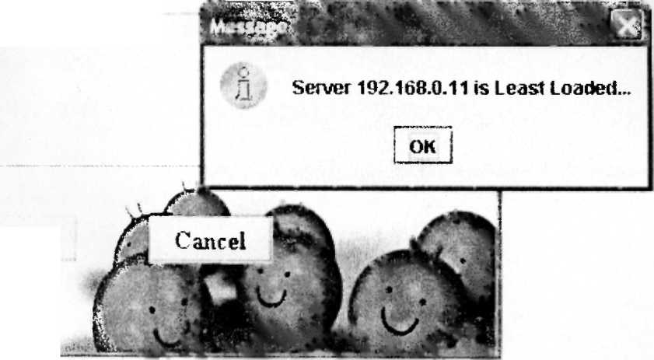
Send
allocate ill tava tiles
Report-Client Status
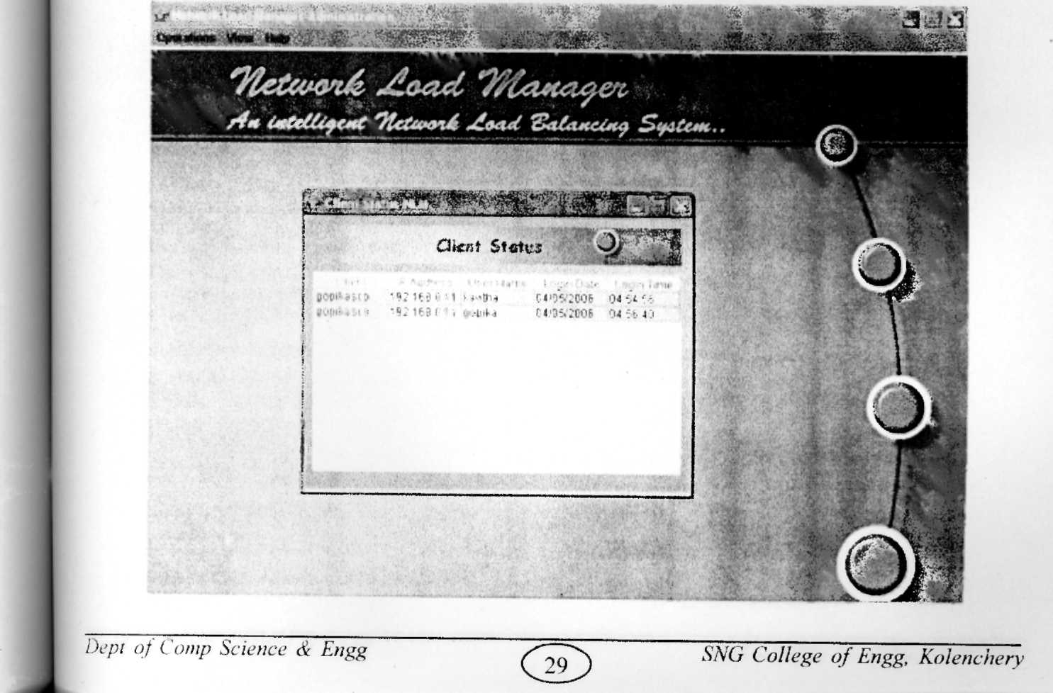

CONCLUSION

CONCLUSION

Finally the system NETWORK LOAD MANAGER is ready to delivered for the client. But still only a significant part of the application has been finished but still lot more extensions are yet to get completed but that will require a lot of time.

The use of CPU load for the purpose of load balancing is a very attractive prospect. Load balancing is an important way to maximize network efficiency.
APPENDIX


APPENDIX 1

Abbreviations
V.
SQL' - Structured query language DBMS - Database management system SRS - Software requirement specification DDD - Detailed Design Document J2EE - Java 2 Platform, Enterprise Edition RMI - Remote Method Invocation

Definitions

SQL-The structured query language, SQL is a query language, which is used with relational databases. A query is a statement requesting the retrieval of information. The portion of a
[ DML that involves information retrieval is called a query language. SQL uses a combination
f of relational algebra and relational-calculus constructs.

DBMS- A database-management system (DBMS) consists of a collection of interrelated | data and set of programs to access that data. Collection of data, usually referred to as database, contains information about one particular enterprise.

SRS- Important purpose of the process of developing an SRS is helping the clients to understand their own needs. It helps in reducing the development cost.

I DDD-lt is an important document for developing the designs, i.e. tables E-R diagrams, data flow diagrams.

J2EE
The Software Development Kit (SDK) comes mainly in 3 forms: Java2 Standard Edition (J2SE) Java2 Mobile Edition (J2ME) Java2 Enterprise Edition (J2EE)
J2EE is a very effective concept used to build large scale components. It is an updated version of Java. The Java Community Programs (JCP) formed it. Today, more and more developers want to write distributed transactional applications for the enterprise and thereby leverage the speed, security, and reliability of server-side technology. To reduce costs and fast-track application design and development, the Java 2 Platform, Enterprise Edition (J2EE) offers a muttered distributed application model, reusable components, a unified security model, flexible transaction control.

Your platform-independent J2EE component-based solutions are not tied to the [products and application programming interfaces (APIs) of any one vendor. Vendors and ■ customers enjoy the freedom to choose the products and components that best meet [their business and technological requirements. J2EE is a very effective concept used to
build large scale components. It is an updated version of Java. The Java Community
Programs (JCP) formed it.

RMI
A J2EE application and its components can invoke objects located on a different ^JVM by using the Java Remote Method Invocation (RMI) system. RMI is used for remote ^communication between Java applications and components, both of which must be written in Java programming language. RMI is used to connect together a client and a server. A client is an application or component that requires the services of an object to fulfill a \request. A server creates an application or component that requires the services of an object available to the clients. A client contacts the server to reference and invoke the object using RMI.

APPENDIX II

Sample codes:

Login. Java

import Java.sql.*; import Java, util.*; import java.text.*; ' import javax.swing.*; import Java.awt.event.*; import Java.awt.*; importjava.net.*;
public class login extends javax.swing. JFrame { Connection con; Statement stmt; ResultSet rs,rs1,rs2; Java.util.Date d=new Java.util.Date(); Java. util. Date t=new Java. util. Date(); /** Creates new form login */ public login() {
initComponents();
setSize(800,600);
■
btreg.setVisible(false); txtusername.requestFocusO;
setDefaultCloseOperation(DO_NOTHING_ON_CLOSE); try{
Class.forName("sun.jdbc.odbc.JdbcOdbcDriver"); con=DriverManager.getConnection("jdbc:odbc:NLM","sa","sa"); stmt=con.createStatement(); } catch(Exception err){
//System.out.Println("SL Error"+err);
}
/** This method is called from within the constructor to
- initialize the form.
- WARNING: Do NOT modify this code. The content of this method is
- always regenerated by the Form Editor.
*/
private void initComponents() {//GEN-BEGIN:initComponents jLabeH = new javax.swing.JLabel(); txtusername = new javax.swing. JTextField(); jLabel2 = new javax.swing.JLabel(); jLabel3 = new javax.swing. JLabel(); cmbusertype = newjavax.swing.JComboBox(); btcancel = newjavax.swing.JButton(); btlogin = newjavax.swing.JButton(); txtpassword = new javax.swing. JPasswordField(); btreg = new javax.swing. JButton(); getContentPane().setLayout(null);
addWindowListener(new java.awt.event. WindowAdapter() { public void windowClosing(java.awt.event.WindowEvent evt) { exitForm(evt);
}
});
jLabeH.setFont(newJava.awt.Font("MS Sans Serif", 1, 11)); jLabel1.setForeground(newjava.awt.Color(0, 51, 204)); jLabeM .setText("User Name"); getContentPane().add(jLabel1); jLabel1.setBounds(530, 320, 90, 30); getContentPane().add(txtusername); txtusername.setBounds(630, 330,130, 20); jLabel2.setFont(newjava.awt.Font("MS Sans Serif, 1, 11)); jLabel2.setForeground(newjava.awt.Color(0, 51, 204)); jLabel2.setText("Password"); getContentPane().add(jLabel2); jLabel2.setBounds(530, 370, 60, 20);
jLabel3.setFont(newjava.awt.Font("MSSans Serif", 1,11)); jLabel3.setForeground(newjava.awt.Color(0, 0, 204)); jLabel3.setText("User Type"); getContentPane().add(jLabel3); jLabel3.setBounds(530, 280, 100, 30);
cmbusertype.setModel(new javax. swing. DefaultComboBoxModel
(new Stringf] {"Admin", "User"})); cmbusertype.addActionListener(newjava.awt.event.ActionListener() { public void actionPerformed(java.awt.event.ActionEvent evt) { cmbusertypeActionPerformed(evt); }
});
getContentPane().add(cmbusertype); cmbusertype.setBounds(630, 280, 130, 20); btcancel.setText("Cancel");
btcancel.addMouseListener(newjava.awt.event.MouseAdapter() { public void mouseClicked(java.awt.event.MouseEvent evt) { btcancelMouseClicked(evt);
}
});
getContentPane().add(btcancel); btcancel.setBounds(660, 420, 80, 30); btlogin.setText("Login");
btlogin.setPreferredSize(newjava.awt.Dimension(80, 50)); btlogin.addActionListener(newjava.awt.event.Actionl_istener() { public void actionPerformed(java.awt.event.ActionEvent evt) { btloginActionPerformed(evt);
}
});
btlogin.addMouseListener(newjava.awt.event.MouseAdapter(){ public void mouseClicked(java.awt.event.MouseEvent evt) { btloginMouseClicked(evt);
}
»;
getContentPane().add(btlogin); btlogin.setBounds(530, 420, 80, 30); getContentPane().add(txtpassword); txtpassword.setBounds(630, 370, 130, 20); btreg.setText("New User Registration"); btreg.addActionListener(newjava.awt.event.ActionListener() { public void actionPerformed(java.awt.event.ActionEvent evt) { btregActionPerformed(evt);
}
});
getContentPane().add(btreg); btreg.setBounds(530, 480, 210, 23); pack();
}//GEN-END:initComponents
private void btregActionPerformed(java.awt.event.ActionEvent evt) {//GEN-FIRST: event_btregActionPerformed
// TODO add your handling code here: Userinfo ui=new Userinfo(); ui.setVisible(true); }//GEN-l_AST:event_btregActionPerformed
private void cmbusertypeActionPerformed(java.awt.event.ActionEvent evt) {// GEN-FIRST:event_cmbusertypeActionPerformed // TODO add your handling code here: String s=(String)cmbusertype.getSelectedltem(); if(s.equals("User"))
{
btreg.setVisible(true);
}
else{
btreg.setVisible(false);
}
}//GEN-l_AST:event_cmbusertypeActionPerformed
private void btcancelMouseClicked(java.awt.event.MouseEvent evt) {//GEN-FIRST:event_btcancellvlouseClicked
Dept of Comp Science & Engg
II TODO add your handling code here: dispose();
}//GEN-LAST:event_btcancelMouseClicked
private void btloginMouseClicked(java.awt.event.MouseEvent evt) {//GEN-FIRST:event_btloginMouseClicked
// TODO add your handling code here:
String usertype=(String)cmbusertype.getSelectedltem();
String username=txtusername.getText();
String password=txtpassword.getText();
MenuAdmin ob=new MenuAdmin();
usermenu ob1=new usermenu();
if((username.equals(" "))||(password.equals("")))
\ {
JOptionPane.showMessageDialog(null,"fields can't be empty"); txtusername.setText(""); txtpassword.setText(""); txtusername.requestFocus(); return;
}
String uname-'select * from login where loginid="'+username+"'and password="'+password+"'and usertype="'+usertype+"'"; try{
rs=stmt.executeQuery(uname); if(rs.next())
\ {
String name=rs.getString("loginid"); String pass=rs.getString("password"); String type=rs.getString("usertype"); if(usertype.equals("Admin"))
\ {
JOptionPane.showMessageDialog(null,"Login Successfully","Login lnformation",JOptionPane.lNFORMATION_MESSAGE);
dispose(); ob.setVisible(true);
return;
} I
JOptionPane.showMessageDialog(null,"Login Successfully","Login
lnformation",JOptionPane.lNFORMATION_MESSAGE);
dispose();
obl.setVisible(true);
SimpleDateFormat dd=new SimpleDateFormat("MM/dd/yyyy");
String s=dd.format(d);
System.out.println(s);
SimpleDateFormat tt=new SimpleDateFormat("hh:mm:ss");
String s1=tt.format(t);
System.out.println(s1);
InetAddress in=lnetAddress.getLocalHost();
String IP=in.getHostAddress();
String hname=in.getHostName();
System.out.println(IP);
String sqlip="select computername from ip where ipaddress='"+IP+"'"; String sqlu="select loginid from userstatus where loginid='"+name+"'"; rs=stmt.executeQuery(sqlu);
if(rs.next()) {String sql2="update userstatus set status-Logon',computername="'+hname+'" where loginid='"+name+'""; stmt.executeUpdate(sql2);
}
else{ String sqluserstatus="insert into userstatus
"+"(loginid,status,computemame)"+"Values("'+name+"','Logon',"'+hname+"')"; stmt.executeUpdate(sqluserstatus);
}
//String sqluser="select username from userdetails,login where login.loginid-"+username+"' and login.loginid=userdetails.loginid"; rs=stmt.executeQuery(sqlip);

// stmt.executeUpdate(sql2); //rs=stmt.executeQuery(sqluser); if(rs.nextQ)
{
String cmp=rs.getString("computername"); // String u=rs.getString("username");
String sql="insert into clientdetails
V'(computemamejoginumejogindate,^ stmt.executeUpdate(sql);}
}
else{
JOptionPane.showMessageDialog(null,"Invalid Login—Try Again"); txtusername.setText(""); txtpassword.setText(""); txtusername.requestFocus(); return;
} "
}
catch(Exception e){ System.out.println(e); }
//if(utype==) }//GEN-LAST:event_btloginMouseClicked
private void btloginActionPerformed(java.awt.event.ActionEvent evt) {//GEN-FIRST:event_btloginActionPerformed
// TODO add your handling code here: }//GEN-LAST:event_btloginActionPerformed /** Exit the Application */
private void exitForm(java.awt.event.WindowEvent evt) {//GENS Fl RST:event_exitForm
System.exit(O); }//GEN-LAST:event_exitForm
J**
>param args the command line arguments
7
public static void main(String args[]) { new login().show();

}
//Variables declaration - do not modify//GEN-BEGIN:variables

pr pr pr pr pr pr pr pr pr
vate javax.swing.JButton btcancel;
vate javax.swing.JButton btlogin;
vate javax.swing.JButton btreg;
vate javax.swing. JComboBox cmbusertype;
vate javax.swing. JLabel jLabeM;
vate javax.swing.JLabel jLabel2;
vate javax.swing. JLabel jLabel3;
vate javax.swing. JPasswordField txtpassword;
vate javax.swing. JTextField txtusername;

// End of variables declaration//GEN-END:variables
}

Messinter.iava import Java.rmi.*; importjava.net.*; import Java, io.*;
public interface messinter extends Remote {
public void sendmess(String address,String message)throws RemoteException;
}
Messserver.java import Java, rmi.*; import Java.rmi.server.*; import Java.io.*; import Java.awt.*; import Java.awt.event.*; import Java, util.*; import javax.swing.*; import javax.swing.border.*; import javax.swing.event.*;
public class messserver extends UnicastRemoteObject implements messinter,ActionListener

{ JFramef; JPanel p1,p2; JScrollPane scroll; JLabel 11,12,13,14,15,16,17; J Button reply.close; JList list; JTextArea ta;
public messserver()throws RemoteException
{
super();
}
public void sendmess(String addr.String mess) {
String address=addr; String message=mess; f=new JFrame(); f,setTitle(" Message");
f.setDefaultCloseOperation(JFrame.DISPOSE_ON_CLOSE); p1=new JPanel();
p1 .setBackground(new Color(205,205,205)); p1 .setBorder(new LineBorder(new Color(205,205,205),6)); pl.setLayout(null); p2=new JPanel(); p2.setBackground(new Color(205,205,205)); p2.setBorder(new LineBorder(new Color(205,205,205),2)); p2.setLayout(null);
11 =newJLabel("INSTANT MESSAGE"); H.setFont(new Font("Times New Roman",Font.BOLD,18)); 11.setForeground(newColor(163,28,28)); 11 .setBounds(80,0,400,50); p1.add(H); /* I2=new JLabelfMessage Details"); l2.setForeground(new Color(255,255,255)); !2.setFont(new Font("Times New Roman",Font.BOLD,16));

l2.setBounds(90,0,125,20); p2.add(l2);

4=new JLabel("Client Name");
l4.setForeground(newColor(255,255,255));
l4.setFont(new Font("Times New Roman",Font.BOLD,14));
l4.setBounds(110,25,150,20);
p2.add(l4);*/H6=new JLabel(" Message");
l6.setForeground(new Color(10,100,200));
l6.setFont(new Font("Times New Roman",Font.BOLD,12));
l6.setBounds(20,140,200,20);
p1 .add(l6);*/ ta=new JTextArea();
ta.setLineWrap(true);
ta. setWrapStyleWord (true);
ta.setFont(new Font("Times New Roman",Font.PLAIN,16));
ta.setForeground(new Color(0,0,255));
scroll.setBorder(new LineBorder(new Color(100,100,100),2));
scroll.setBounds(20,80,300,105);
scroll.getViewport().add(ta);
pl.add(scroll);
/* reply=new JButton("Reply"); reply.setBackground(new Color(150,150,200)); reply.setForeground(new Color(155,255,255)); reply.setFont(new Font("Times New Roman",Font.BOLD,16)); reply.setBounds(60,305,80,30); . reply.addActionListener(this); pl.add(reply);*/ close=new JButton("Close"); close.setBackground(new Color(150,150,200)); close.setForeground(new Color(155,255,255)); close.setFont(new Font("Times New Roman",Font.BOLD,16)); close.setBounds(130,205,80,30); close.addActionListener(this); pl.add(close);
Icon icon=new lmagelcon("menu.gif);

JLabel image=new JLabel(icon);
image.setlcon(icon);
image.setBounds(0,0,480,450);
pl.add(image);
//Icon icon=new lmagelconfbg3.jpg"); //JLabel image=new JLabel(icon); //image.setlcon(icon); //image.setBounds(0,0,402,482); //pl.add(image); f .getContentPane().add(p1); f.setLocation(30,30); f.setResizable(false); f.setSize(350,300); f.setVisible(true);
}
public void actionPerformed(ActionEvent ae) {
if(ae.getSource()==reply) {
new sendmess();
}
if(ae.getSource()==close) {
f.dispose();
} }
public static void main(String args[])
{
try {
messserver ms=new messserver(); Naming.rebind("messserver",ms);
}
catch(Exception e){}

}
} m
Sendmess.java

import Java.rmi.*; import Java.awt.*; import Java.awt.event.*; import Java.util.*; import javax.swing.*; import javax.swing.border.*; import javax.swing.event.*; import Java, io.*; import Java.sql.*;
public class sendmess extends JFrame implements ActionListener
{
Connection con;
Statement stmt;
ResultSet rs,rs1,rs2;
Java.util.Date t=new Java.util.Date();
private JPanel p1,p2;
private JLabel 11,12,15,16;
//private JComboBox cbgname,cbcname;
//private ButtonGroup bg;
//private JRadioButton single,groups,all;
private JScrollPane scroll;
private JTextArea ta;
private JTextField tf;
private JButton send,cancel;

public sendmess() {
setTitle("Send Messages"); getContentPane().setLayout(null);
setDefaultCloseOperation(JFrame.DISPOSE_ON_CLOSE);

Dept of Comp Science & Engg PTTS ^{SNG} ^{Colle}S^{e} of Engg, Kolenchery
getContentPane().setBackground(newColor(205,205,205)); p1=new JPanel();
p1 .setBackground(new Color(205,205,205));
p1 .setBorder(new LineBorder(new Color(208,208,208),4));
p1 .setLayout(null);
p1.setBounds(1,1,472,441);
p2=new JPanel();
p2.setBackground(new Color(205,205,205));
//p2.setBorder(new LineBorder(new Color(100,100,100),3));
p2.setl_ayout(null);
p2.setBounds(200,50,250,160);
11 =newJLabel("MESSAGE SENDING");
11 .setFont(new Font("Times New Roman",Font.BOLD,20));
11 .setForeground(new Color(163,28,28));
11 .setBounds(140,10,200,30);
p1.add(M);
* I5=new JLabel("Client Name");
l5.setFont(new Font("Times New Roman",Font.BOLD,12)); l5.setForeground(new Color(0,0,0)); l5.setBounds(20,75,100,20); p2.add(l5);*/
I6=new JLabel("Type Your Message Here"); l6.setFont(new Font("Times New Roman",Font.BOLD,14)); l6.setForeground(new Color(10,10,10)); l6.setBounds(50,85,200,30); p1.add(l6);
* tf=new JTextField(); tf.setBounds(100,110,120,25); p2.add(tf);
p1.add(p2);*/
ta=new JTextArea();
ta.setLineWrap(true);
ta. setWrapStyleWord (true);
ta.setFont(new Font("Times New Roman",Font.PLAIN,16));
ta.setForeground(new Color(0,0,255)); scroll=new
scroll.setB'ounds(100,150,250,100); scroll.getViewport().add(ta); p1 .add(scroll); cancel=new JButton("Cancel"); cancel.setBackground(new Color(150,150,200)); cancel.setForeground(new Color(155,255,255)); cancel.setFont(new Font("Times New Roman",Font.BOLD,16)); cancel.setBounds(250,280,80,30); pl.add(cancel);
cancel.addActionListener(this); send=new JButton("Send"); send.setBackground(new Color(150,150,200)); send.setForeground(new Color(155,255,255)); //send.setBackground(newColor(205,205,205)); //send.setForeground(Color.black);
send.setFont(new Font("Times New Roman",Font.BOLD,16));
send.setBounds(125,280,80,30);
pl.add(send);
send.addActionListener(this); Icon icon=new lmagelcon("menu.gif); JLabel image=new JLabel(icon); image, setlcon(icon); image.setBounds(0,0,480,450); pl.add(image); getContentPane().add(p1); setLocation(30,30); setResizable(false); setSize(480,400); setVisible(true); try{
Class.forName("sun.jdbc.odbc.JdbcOdbcDriver"); con=DriverManager.getConnection("jdbc:odbc:NLM","sa","sa");

stmt=con. createStatement();

} catch(Exception err){
//System.out.Printlnf'SL Error"+err);
}
}
public void actionPerformed(ActionEvent ae)
{
if(ae.getSource()==send)
{
try{
String sql2="select computername from cpuusage order by usage"; rs1 =stmt.executeQuery(sql2); if(rs1.next()) {
String cmp=rs1 .getString(l); // String cmp=rs.getString(0); // System.out.println(cmp);

String ipsql="select ipaddress from ip where computername="'+cmp+""';
rs2=stmt.executeQuery(ipsql);
if(rs2.next())
{
String ip=rs2.getString("ipaddress");
JOptionPane.showMessageDialog(null,"Server "+ip+" is Least Loaded...");
String message=ta.getText();
messinter in=(messinter)Naming.lookup("rmi://"+ip+7messserver"); in.sendmess(ip,message); // System.out.println(message); }
}
}catch(Exception e){

//JOptionPane.showMessageDialog(null,"Server not connected'7'Connection Status",JOptionPane.ERROR_MESSAGE); }
}
else if(ae.getSource()==cancel) this.dispose();
}

public static void main(String args[]) {
new sendmess();

}
REFERENCES

-A.Korth, HF, &Sudarshan, S., 1998 Database management systems, 3rd ed, McGraw-Hill, NewYork, 560p

-Pankaj Jalote,1997 Integrated approach to software engineering 2nd ed.Narosa publishing house,497p

- Jim Keogh, The complete Reference J2EE Tata McGraw-hill edition ,886p

